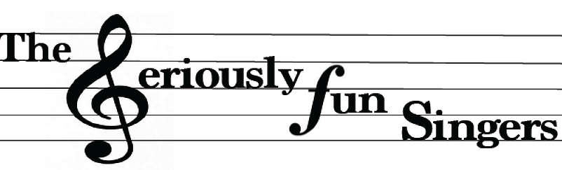
Invite you to our
Spring Performance!

We again offer our signature eclectic mix:
From 16th Century Madrigals to 21st Century Bruno Mars

Join us for the music and stay for refreshments afterward.
Sunday, May 19 from 5:00 to 7:00 pm
Chevy Chase Village Hall
5906 Connecticut Avenue *

RSVP by simply responding to this email

*Link to Village Hall Parking Map
http://www.chevychasevillagemd.gov/DocumentCenter/Home/View/386
Limited street parking so carpooling is encouraged!

